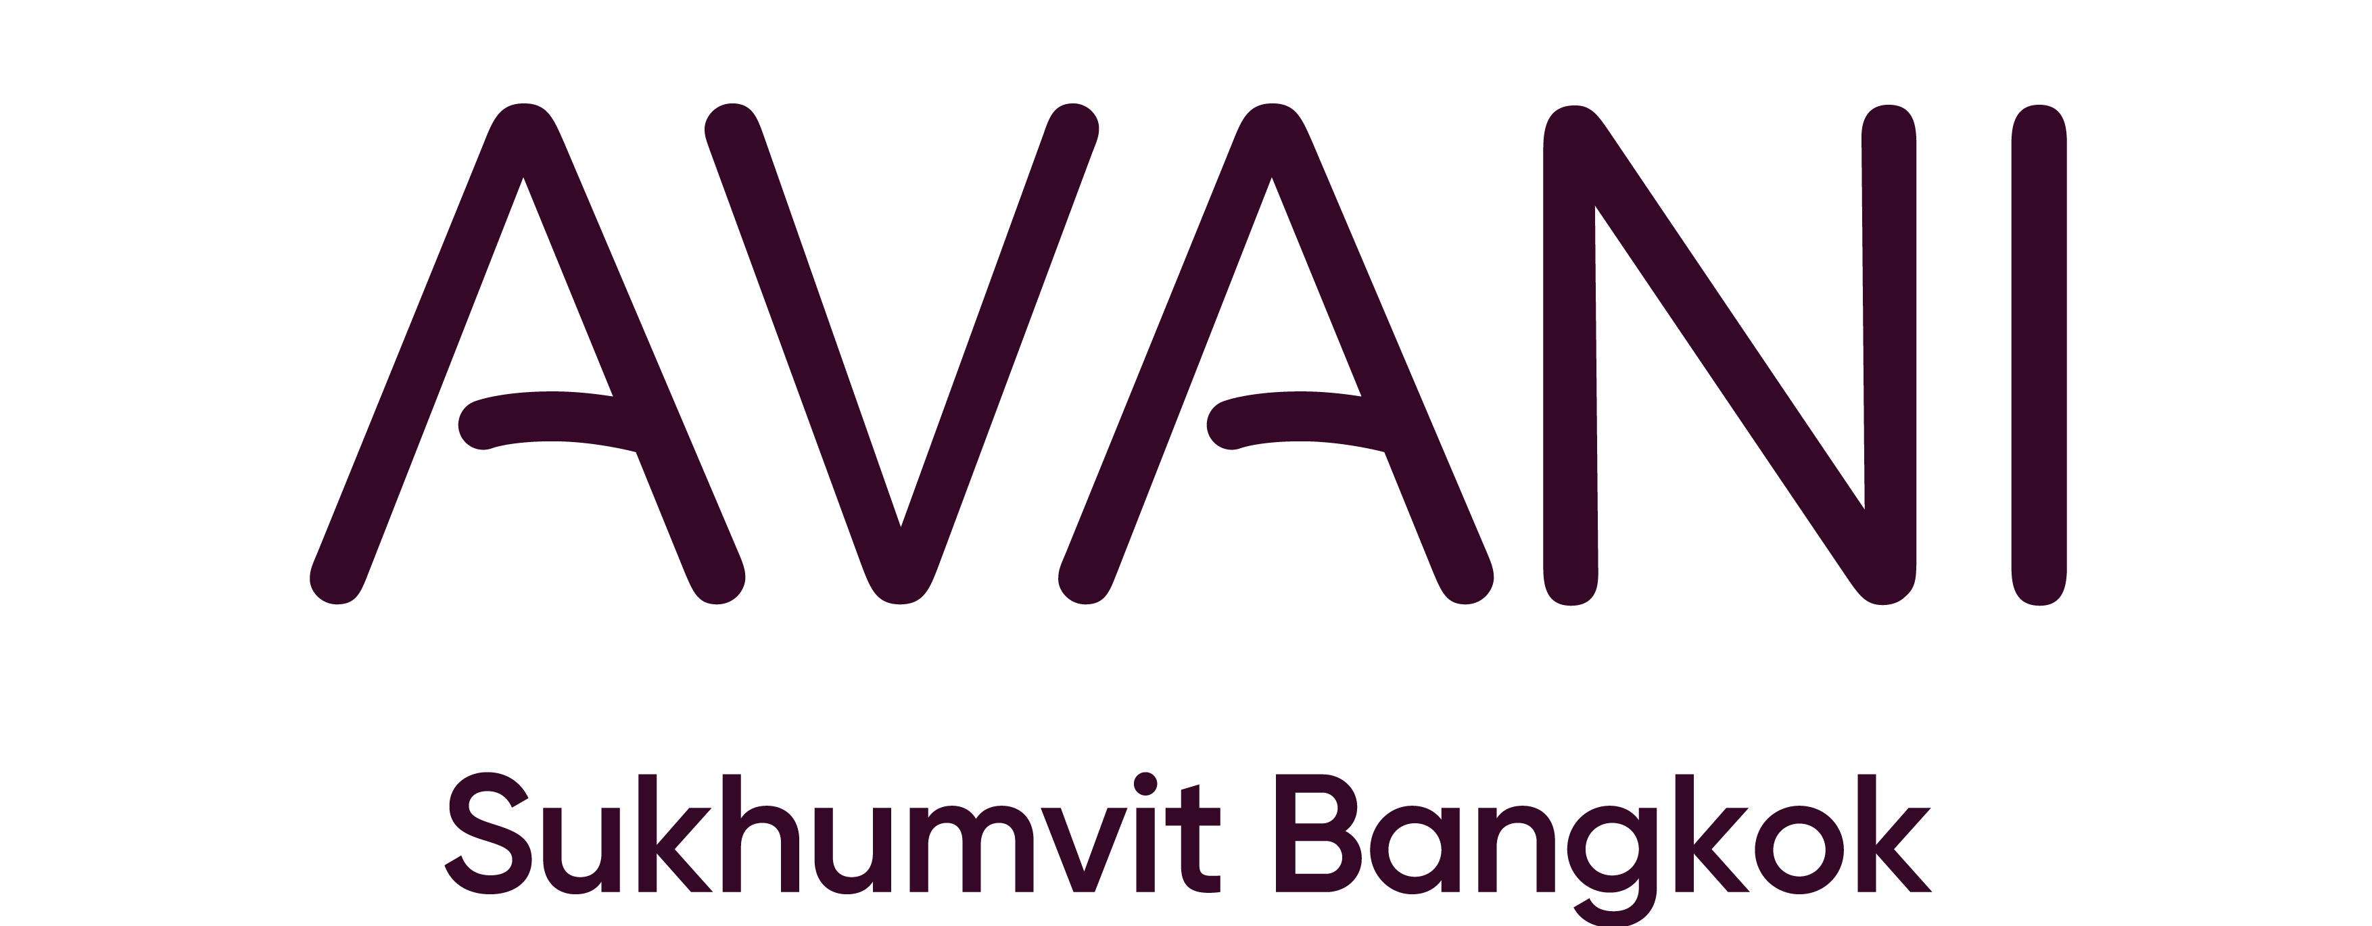

HOTEL RESERVATION – TEST & GO FORM
Agritechnica Asia and Horti Asia 2022 | May 25 - 27, 2022

Please return this completed from to emails: res.vsuk@avanihotels.com cc: Junyaphorn_pr@avanihotels.com by April 30, 2022

RESERVATION DETAILS
Check - in Date: |  |  |  |  | Arrival Flight: |  |  |  | ETA:
Check - out Date: |  |  |  |  | Departure Flight: |  |  |  | ETD:
Salutation: |  | Dr. Mr. Mrs. Ms.
First Name: |  |  |  |  | Last Name:
Phone: |  |  |  |  | Email:
Package |  |  |  | Room Type | Room Rate |  |  |  | No. of room | No. of Adults
Test & Go |  |  |  | Avani Room | 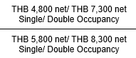
 |  |  |  | Avani Deluxe Room
Preference: | Smoking |  |  | Non-Smoking | King Bed Twin Bed
Remarks:
- Room rates are inclusive of 10% service charge and current applicable tax of 7.7%
- Daily breakfast
- One-Time Covid-19 RT-PCR Test
- Transportation from Suvarnabhumi or Don Mueang Airport to Avani Sukhumvit Bangkok Hotel for Day 1
- According to Thai government regulations, all travelers arriving in Thailand, including children under 4 years old, must undergo a RT-PCR test on the arrival date. The additional price for children under 4 years old's RT-PCR test is THB 3,000 net per person per test
- Full pre-payment is required at the time of booking.
- This package is only available to fully vaccinated travelers.
RESERVATION GUARANTEE
A credit card guarantees, and signature of the credit card holder is required at the point of reservation.
I hereby authorize you to debit my credit card in case of cancellation less than 7 days, 24 hours or no-show.
Guaranteed by: |  |  | Credit Card: AMEX / MasterCard / Visa / JCB
Cardholder’s Name: |  |  |  |  |  | Signature:
Credit Card Number: |  |  |  |  |  | Expiry Date:
TERMS AND CONDITIONS
- All reservations forms, changes and cancellations must be made in writing and send to res.vsuk@avanihotels.com
- By providing above mentioned credit card details, cardholder agrees to the reservation guarantee policy.
- A charge for one night inclusive of tax and service charge will be levied in the event of cancellation less than 7 days prior to arrival date. A charge for entire stay inclusive of tax and service charge will be levied in the event of cancellation less than 24 hours prior to arrival date,
- The above rates are valid for guests of Agritechnica Asia and Horti Asia 2022
For Hotel Use Only
(A) Reservation Confirmed (B) Reservation on Waiting List
Room rate per night: Category confirmed:
Reservation Confirmed by:
Name: ____________________________ Confirmation No.: ___________________ Signed by: ________________________
Date: _____________________________ Remarks: ____________________________________________________________

